Generating Images through different AI tools

CHAT GPT
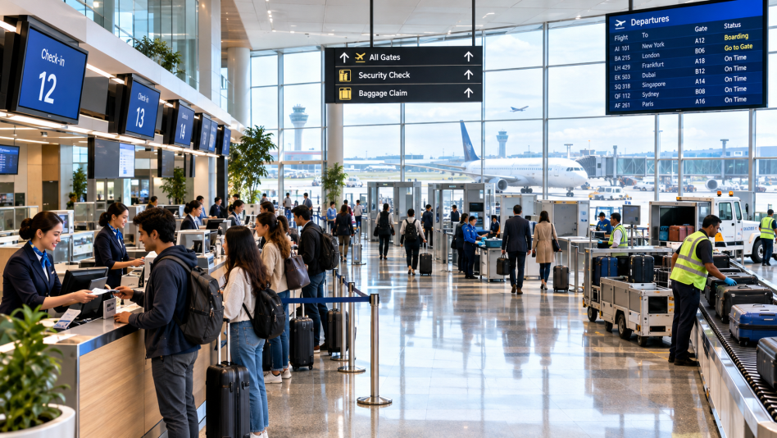
> *Role:* You are a professional aviation industry visual designer creating a corporate marketing image for an international airport.
> *Task:* Create a photorealistic premium aviation industry scene showing a modern international airport during normal operations.
> *Context:* Show diverse young adult passengers checking in for flights, professional airline ground staff assisting passengers, baggage handling operations, digital flight-information displays, airport security facilities, modern terminal architecture, and commercial aircraft visible through large glass windows. The scene should communicate efficient airport operations, passenger experience, technology, and professionalism.
> *Medium:* Photorealistic professional commercial aviation photography, cinematic realism, high-end corporate advertising style.
> *Environment:* Spacious modern international airport terminal with polished floors, glass walls, check-in counters, departure gates, baggage areas, subtle greenery and aircraft visible outside.
> *Lighting:* Soft natural daylight entering through large terminal windows, realistic shadows, balanced exposure, subtle cinematic lighting, natural skin tones and realistic reflections.
> *Constraints:* Accurate aviation details, realistic aircraft proportions, realistic airport equipment, natural human anatomy, no distorted hands or faces, no fictional airline logos, no unnecessary text, no unrealistic objects.
> *Output:* Wide professional composition, 16:9 aspect ratio, high resolution, suitable for an aviation-management presentation and corporate marketing campaign.
GEMINI
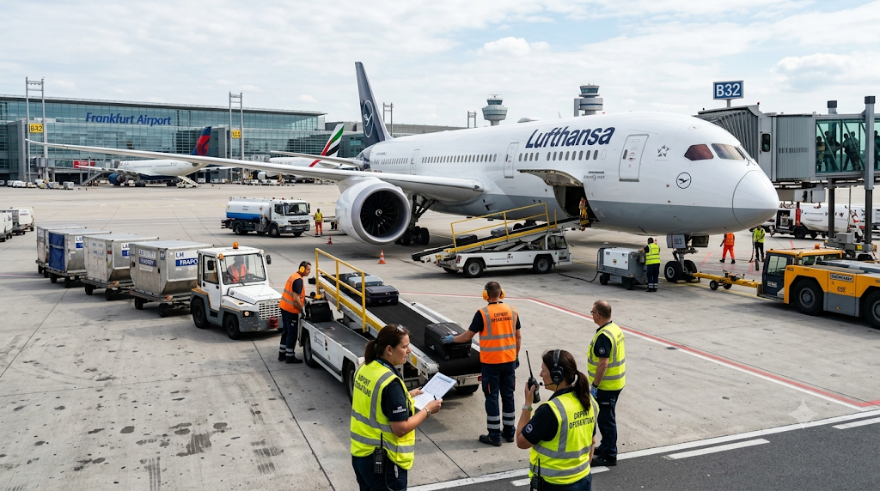
> *Create a photorealistic professional aviation operations scene at a major international airport. Show airport operations staff coordinating aircraft turnaround activities on an active apron, including ground support equipment, baggage loading, passenger boarding, aircraft servicing, ground crew communication and safety procedures. Include a modern passenger aircraft positioned at the gate with realistic airport infrastructure in the background. Use professional aviation documentary photography, realistic daylight, accurate proportions, authentic ground-handling equipment, natural human poses, realistic safety clothing, cinematic depth of field, highly detailed textures, no distorted people, no fictional logos, no unnecessary text, 16:9 aspect ratio.*

CANVA AI
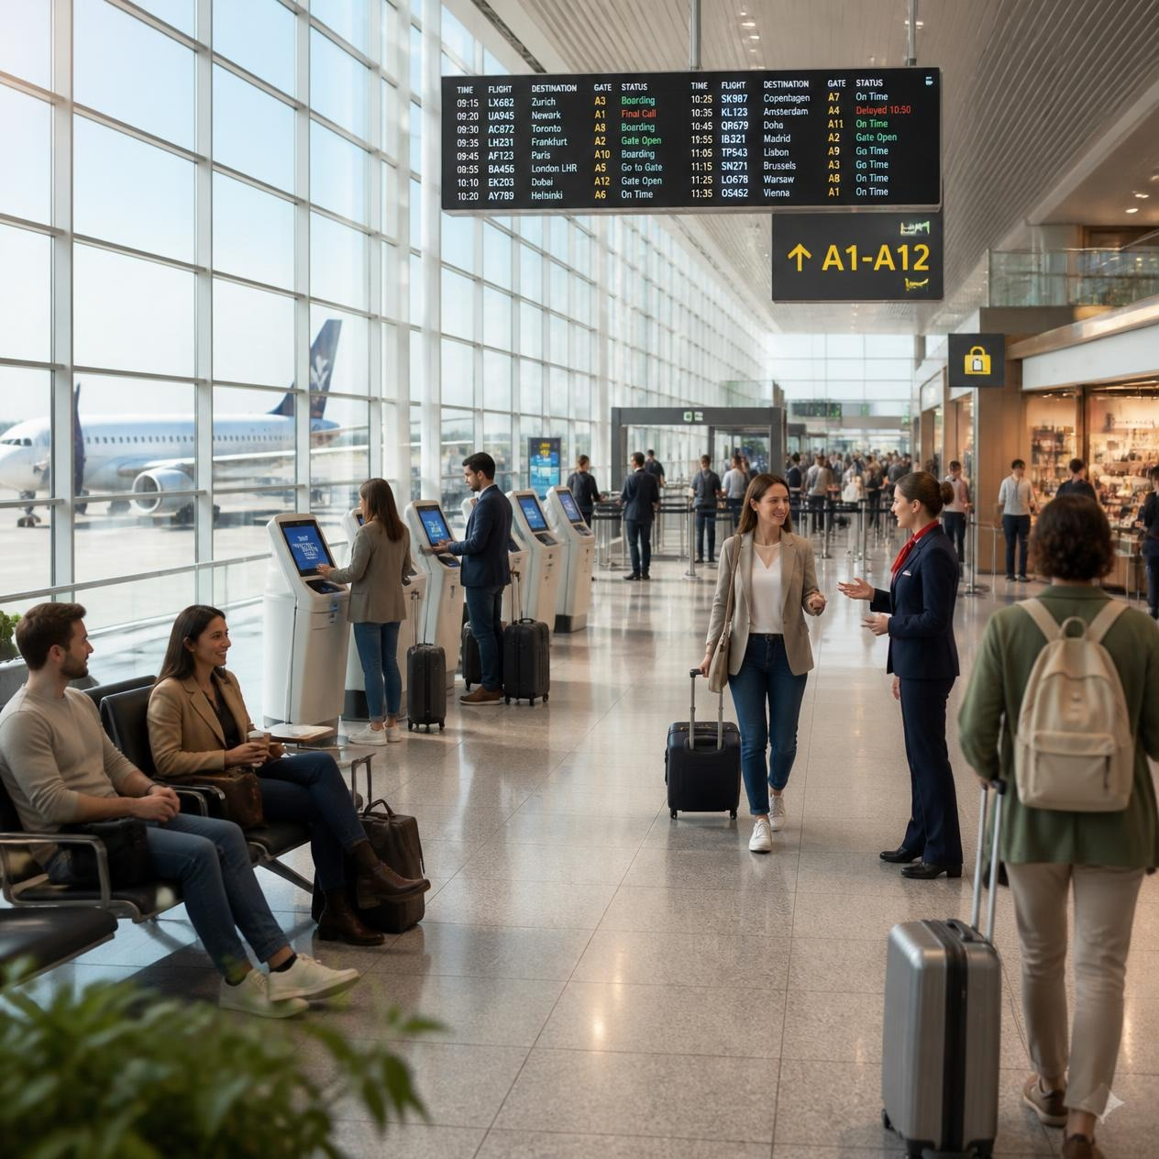
*Create a premium photorealistic aviation marketing image showing an excellent passenger experience at a modern international airport. Show passengers arriving at the terminal, self-check-in kiosks, airline staff assisting travellers, digital flight information displays, security screening, comfortable seating, retail and dining areas, clear airport signage and aircraft visible through panoramic glass windows. The atmosphere should communicate convenience, efficiency, safety and hospitality. Professional commercial photography, realistic human expressions, natural skin texture, soft daylight, modern airport architecture, cinematic but realistic lighting, shallow depth of field, accurate aviation details, 85mm lens, no distorted faces or hands, no unnecessary text, 16:9 aspect ratio.*

PIXLR
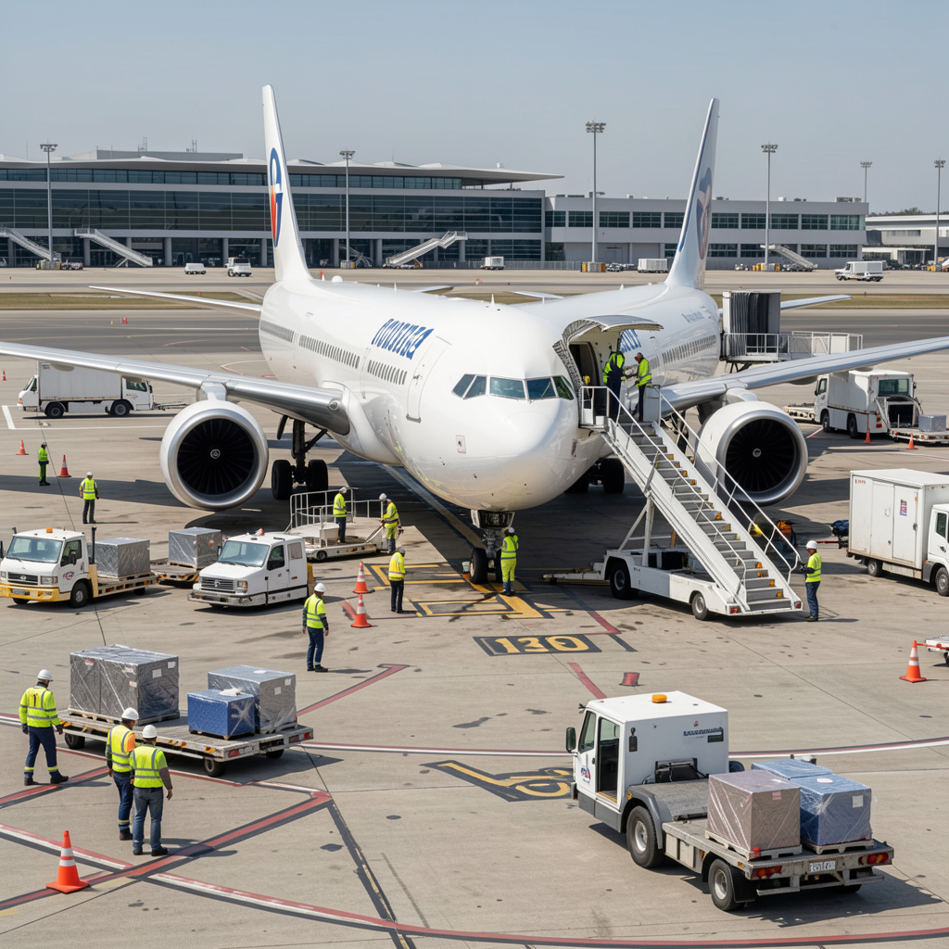
*Create a photorealistic professional image of airline ground-handling operations at a busy international airport. Show trained ground staff performing aircraft turnaround activities including baggage loading, catering service, passenger stairs, ground power equipment and aircraft inspection around a commercial passenger aircraft. Include realistic apron markings, airport vehicles, safety cones, personnel wearing appropriate high-visibility uniforms and a terminal building in the background. Use aviation documentary photography, natural daylight, realistic shadows, accurate aircraft proportions, highly detailed equipment, realistic human anatomy, professional corporate aesthetic, 85mm lens, shallow depth of field, no fictional logos, no unnecessary text, 16:9 aspect ratio.*

KREA AI
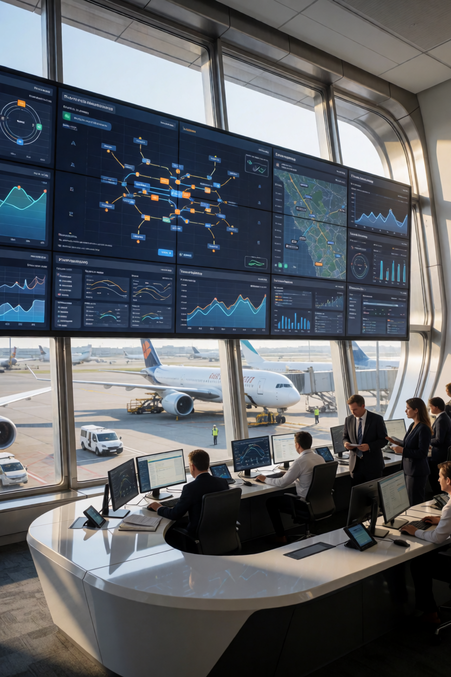
*Create a futuristic but realistic aviation industry scene showing artificial intelligence being used in airport operations. Show airport operations managers monitoring an intelligent digital operations center with real-time aircraft movement information, passenger-flow analytics, baggage tracking, predictive maintenance alerts and airport resource-management dashboards. Through large windows, show aircraft operating on the airport apron. Combine advanced AI technology with realistic existing airport infrastructure. Photorealistic corporate photography, sophisticated aviation environment, realistic digital interfaces, natural lighting, professional employees, cinematic composition, accurate aircraft details, realistic human anatomy, no fake statistics, no distorted screens, no unnecessary text, 16:9 aspect ratio.*

PLAYGROUND AI
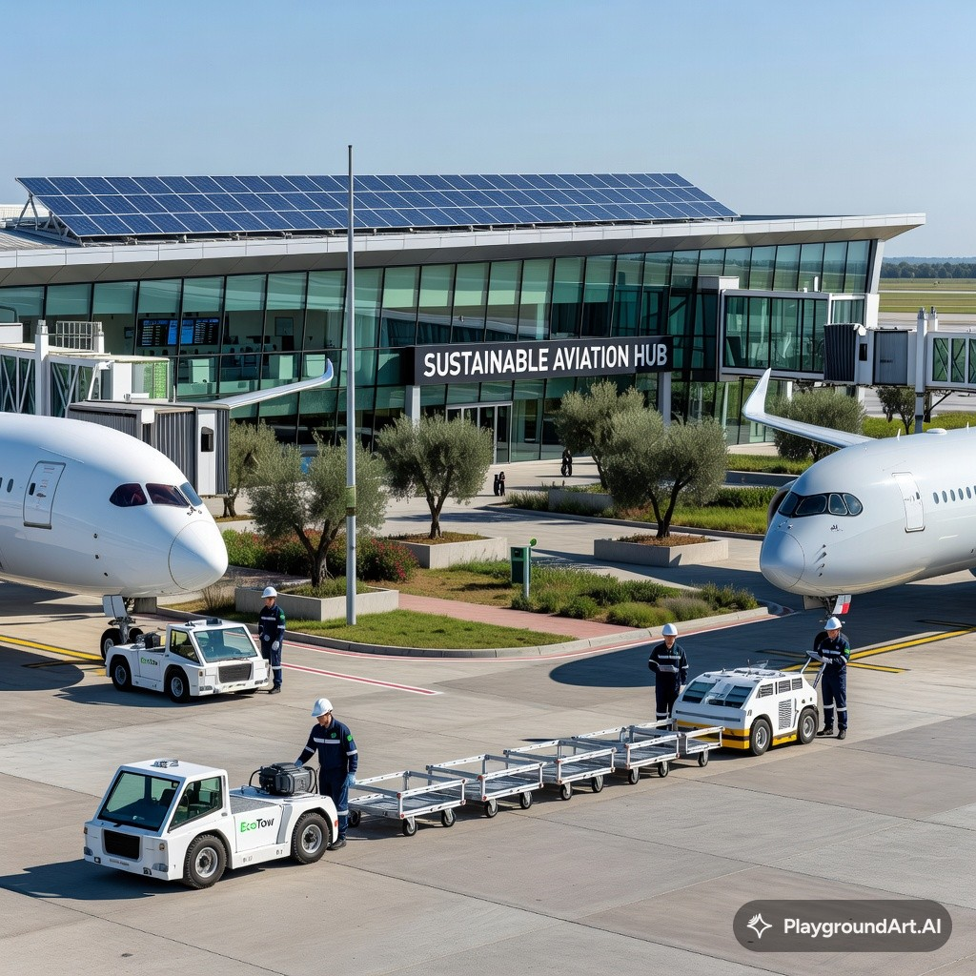
> *Create a photorealistic corporate aviation sustainability scene at a modern international airport. Show commercial aircraft at airport gates alongside electric ground-support vehicles, sustainable airport infrastructure, solar panels, energy-efficient terminal buildings, greenery and employees working in environmentally responsible airport operations. Communicate sustainable aviation and green airport management without creating unrealistic technology. Professional aviation photography, natural daylight, realistic airport architecture, accurate aircraft proportions, cinematic composition, realistic reflections, highly detailed, professional corporate advertising aesthetic, no fictional logos, no unnecessary text, 16:9 aspect ratio.*

OPEN ART AI
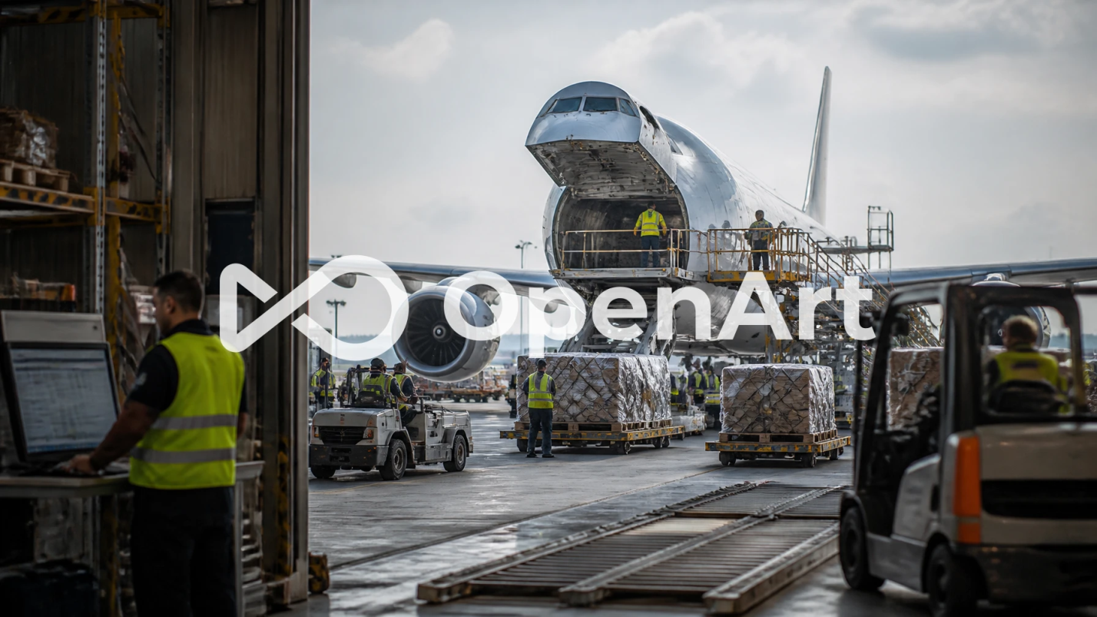
*Create a photorealistic aviation cargo and supply-chain operation at a major international airport. Show cargo aircraft, air-freight containers, ULDs, cargo handling equipment, warehouse workers, forklifts and logistics managers coordinating the movement of freight from an airport cargo terminal toward an aircraft. Include realistic warehouse architecture, loading areas, digital logistics screens and organized cargo operations. Professional aviation documentary photography, realistic industrial environment, natural daylight, cinematic depth of field, accurate cargo equipment and aircraft proportions, realistic people and safety equipment, highly detailed, no fictional logos, no unnecessary text, 16:9 aspect ratio.*

POLLO AI
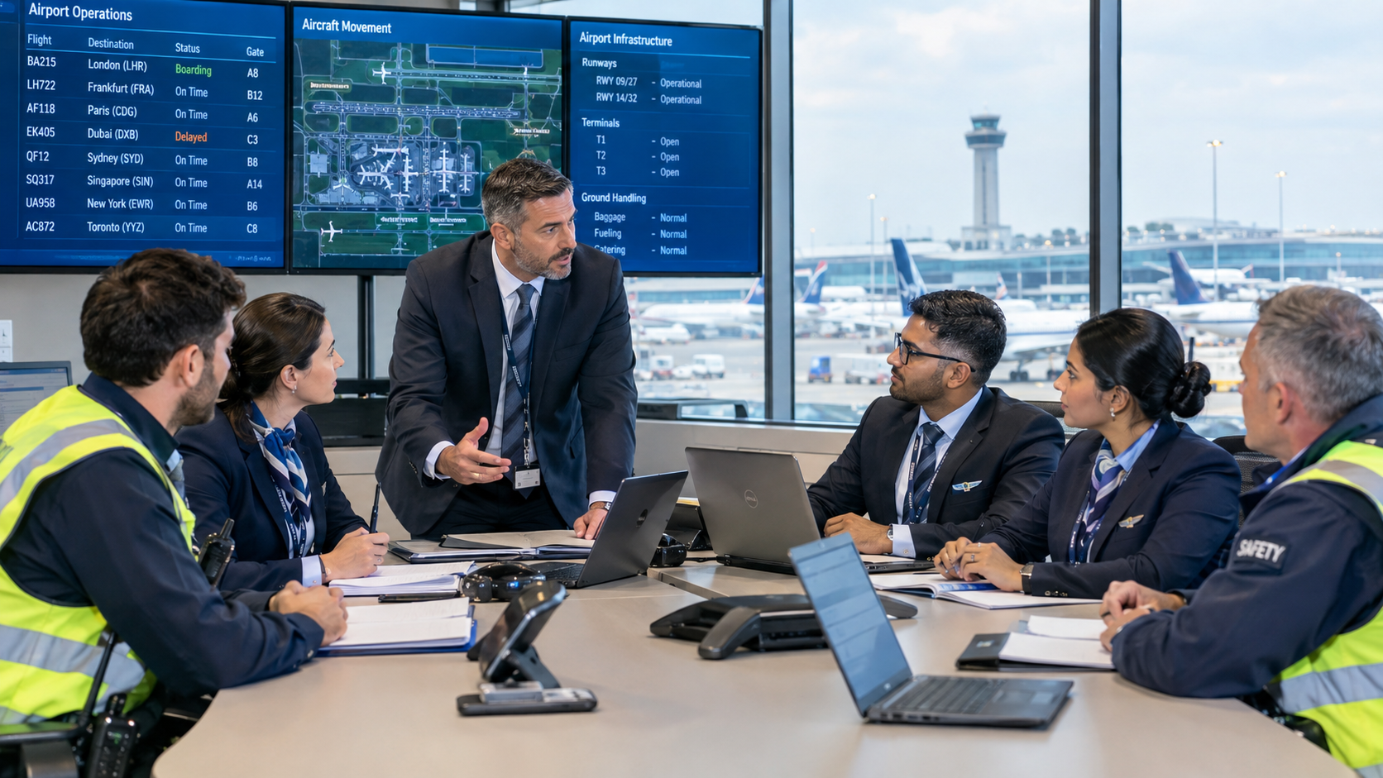
*Create a photorealistic professional corporate photograph of an aviation management team conducting an airport operations briefing. Show an airport manager with airline operations managers, ground-handling supervisors, customer-service managers and safety personnel discussing daily airport operations inside a modern airport operations center. Include realistic digital airport-operation displays, aircraft movement information and airport infrastructure visible through large windows. Professional corporate photography, authentic aviation workplace, natural expressions, realistic skin texture, soft professional lighting, shallow depth of field, accurate aviation details, premium business aesthetic, no distorted hands or faces, no fictional logos, 16:9 aspect ratio.*

